
ATAR Chemistry – Unit 1
Atoms & Elements Assignment
Name:
Score: /30
- Determine the number of protons, neutrons and electrons for the following: [6]

 | Protons | Neutrons | Electrons
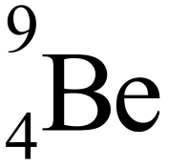 | 4 | 5 | 4
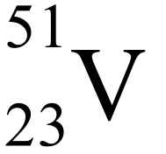 | 23 | 28 | 23
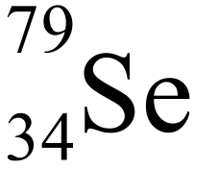 | 34 | 45 | 34
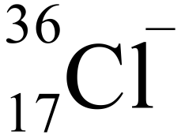 | 17 | 19 | 18

- Identify which of the following may be isotopes: [2]

A & E, C&F

- On the diagram below, indicate where the following groups of elements are located on the periodic table: [3]
  - Metals
  - Non-Metals
  - Metalloids

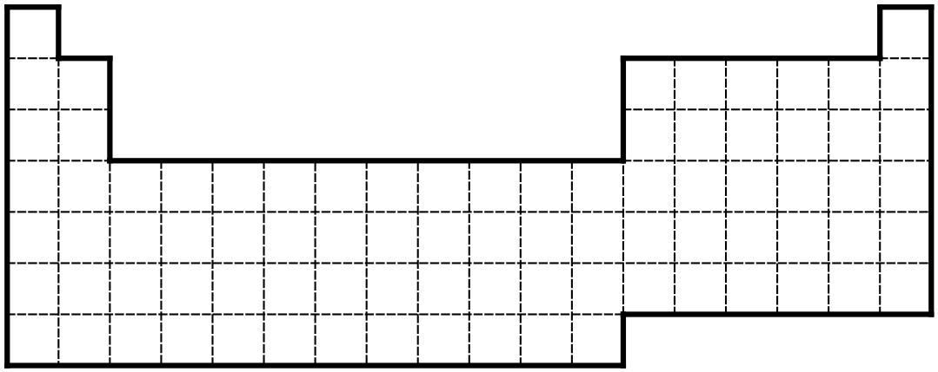

- For the following elements: [6]
  - Draw an electron shell diagram.
  - Write the electron configuration using the 2,8,8,2 rule.
  - Write the electron configuration in s, p, d, f form.
Element | Electron Shell Diagram | Electron Configuration
 |  | 2, 8, 8, 2 | s, p, d, f
Sodium - 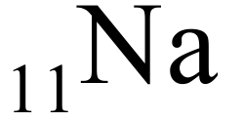 |  | 2,8,1 | 1s² 2s²2s⁶3s¹
Chlorine - 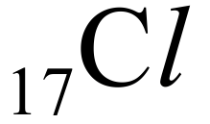 |  | 2,8,7 | 1s² 2s² 2s⁶ 3s² 3p⁵

- Which of the following statements are true? (write T or F) [2]
- Elements become more metallic left to right across periods and less metallic down groups. | F
- Atomic radii decrease moving left to right in periods and increase down groups. | T
- Electronegativity increase left to right across periods and increases down groups. | F
- The elements with the greatest ‘electron affinity’ are to the right and bottom of the periodic table. | F

- Consider the atomic emission spectrums below: [2]
Lithium | 
Sodium | 
Nitrogen | 
UNKNOWN | 

Identify the unknown element, giving reasons for your answer:

Lithium – matching emission spectrum

- To determine the concentration of Lead in a sample of water a student made standard lead solutions, absorption of each was measured. The results of these, and the absorption from a water sample are shown below:

Sample | Concentration (ppm) | Absorbance
Blank | 0∙00 | 0∙00
Sample 1 | 1∙00 | 0∙17
Sample 2 | 2∙00 | 0∙34
Sample 3 | 3∙00 | 0∙48
Sample 4 | 4∙00 | 0∙65
Sample 5 | 5∙00 | 0∙83
Unknown Sample | ? | 0∙53

  - Draw a calibration curve of the data, including a line of best fit. [3]



1 – data, 1 – labels, 1 – line of best fit
  - Use the calibration curve to estimate the concentration of lead in the unknown sample. [2]
1 – show working
1 - ~3.3ppm

- Element ‘E’ occurs in two isotopes. 15% of all atoms of ‘E’ have a relative atomic mass of 51 and the rest a relative atomic mass of 52.
  - In terms of sub-atomic particles, how are these isotopes different: [2]

Same number of protons, different number of neutrons

  - What is the average relative atomic mass for the element E? [2]

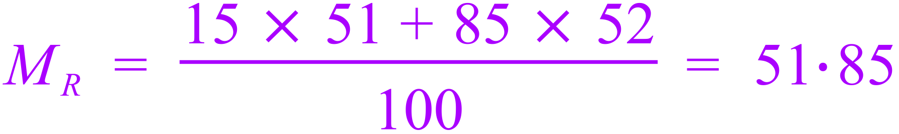

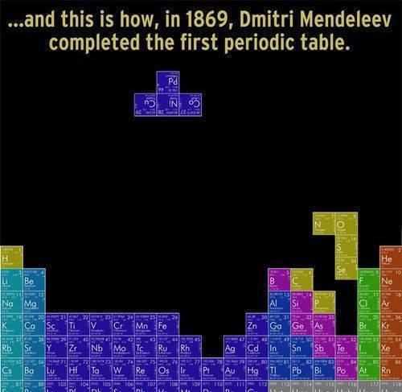

END OF QUIZ

